**Database System Architecture**

The database system architecture can be broadly classified into two main types: Two-tier architecture.

Three-tier architecture (ANSI-SPARC architecture).

**1. Two-tier Architecture:**

It is also known as the client-server architecture.

It consists of two layers: the client layer and the server layer.

In this architecture, the client layer directly communicates with the database server.

The client layer is responsible for user interaction, such as displaying the user interface, collecting user input, and performing data validation.

It handles the presentation logic and user interface components.

The server layer, also known as the database server, manages the database and handles tasks related to data storage, retrieval, and manipulation.

It interacts directly with the database management system (DBMS) to process queries, execute transactions, and manage data integrity and security.

In the two-tier architecture, both the application logic and data access logic reside on the client side.

This architecture is relatively simple but can suffer from issues such as scalability and maintainability, as all the processing tasks are handled on the client side.

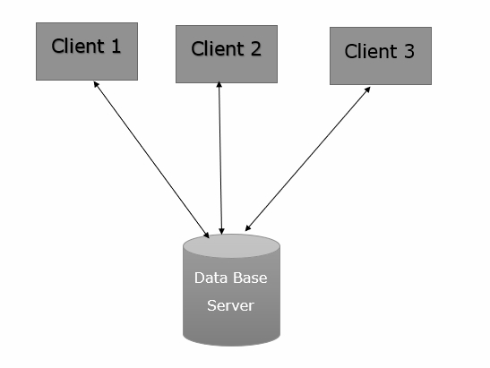

**2. Three Level ANSI-SPARC Architecture:**

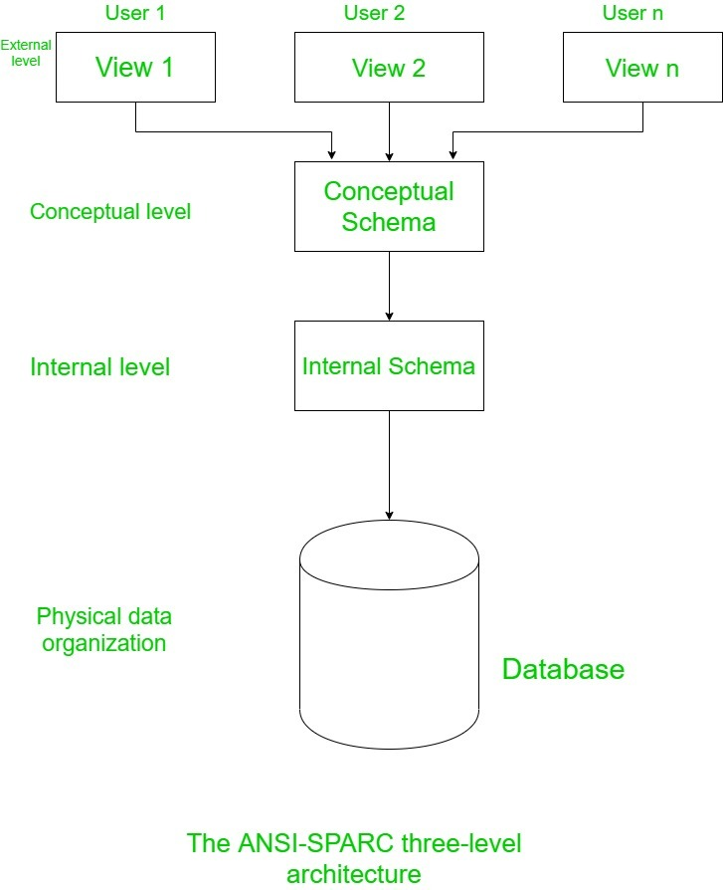

* The ANSI-SPARC (American National Standards Institute, Standards Planning And Requirements Committee) architecture is a widely accepted framework for database system design.
* It defines three levels of abstraction: external level, conceptual level, and internal level.

- **External** Level:

This level represents the user views or user interfaces.

It describes how each user sees the data and defines the individual user's perception of the database. Each user can have a different external view tailored to their specific needs, hiding unnecessary details of the database schema.

- Conceptual Level: The conceptual level represents the overall logical view of the entire database for the entire organization. It describes the entire database schema, including all entities, attributes, and their relationships. It provides a global, integrated view of the database that is independent of any specific application.

- Internal Level: The internal level, also known as the physical level, deals with the physical representation of data in the database. It describes how the data is stored and accessed at the lowest level, such as data structures, indexes, and storage organization. It focuses on optimization techniques for efficient storage and retrieval of data.

The ANSI-SPARC architecture separates the user views (external level) from the overall logical structure (conceptual level) and the physical storage details (internal level). This separation provides flexibility, independence, and data abstraction, allowing changes in one level without affecting the other levels.

By using the ANSI-SPARC architecture, database designers can modify or enhance the database schema, optimize storage structures, or change user interfaces without affecting the entire system, leading to better scalability, maintainability, and adaptability.

It's important to note that the ANSI-SPARC architecture is a conceptual framework and does not dictate a specific implementation or deployment strategy. Actual database management systems (DBMS) may vary in their implementation while adhering to the fundamental principles of the ANSI-SPARC architecture.